**Guide To Installing Stuff and Running Opencl Duco Miner: By eternaldemon**

**WINDOWS USERS:**

1. Install your graphics Driver – AMD/NVIDIA
2. Install Python – preferably 3.8.1 and make sure to check the options – add to PATH & install pip while installing it.
3. Install Visual Studio 2019 Community Edition (<https://visualstudio.microsoft.com/thank-you-downloading-visual-studio/?sku=Community&rel=16>)
4. Inside Visual Studio Install Desktop Development with C++ and below check things. (Try to install as many checked dependencies as you can. Minimal Skipping)

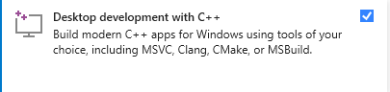

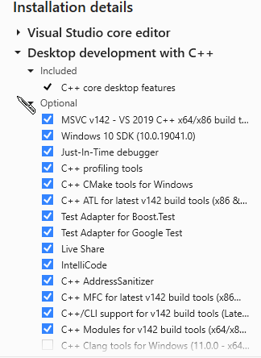

1. NVIDIA GPU? – Install CUDA TOOLKIT (<https://developer.nvidia.com/cuda-downloads>)
2. Intel CPU? – Install Opencl Runtime **18.1 (**<https://registrationcenter.intel.com/en/forms/?productid=3207&pass=yes>). Register and select 18.1 from dropdown list. Install it. If shows error – graphics are installed, then uninstall intel integrated graphics driver and install the runtime.
3. AMD CPU? – Make sure your CPU drivers are installed and are latest in version.
4. Install Pyopencl manually – Go here ( <https://www.lfd.uci.edu/~gohlke/pythonlibs/> ) and search pyopencl. Download this for 64 bit ([pyopencl‑2021.1.5+cl21‑cp38‑cp38‑win_amd64.whl](javascript:;) ) and this for 32 bit ( [pyopencl‑2021.1.5+cl21‑cp38‑cp38‑win32.whl](javascript:;) ).
5. After download the wheel file from above step, go to C/Users/Your_Username/AppData/Local/Programs/Python3.x/Lib/site-packages/ and extract the contents of pyopencl file downloaded in step 7 here. Yes, it can be opened and extracted using 7zip or WinRAR.
6. Now open cmd with admin privileges, and type pip install gputools. Gputools and pyopencl should be installed now.
7. Go here ([https://www.techpowerup.com/download/techpowerup-gpu-z/)](https://www.techpowerup.com/download/techpowerup-gpu-z/)%20) and install GPU-Z to monitor the GPU stats and check whether the following (bottom checkboxes) are enabled or not. INTEL (OPENCL, CUDA are necessary) and AMD (OPENCL is necessary).

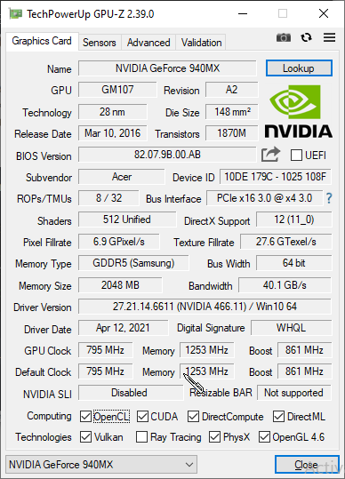

1. Clone the repo or extract the opencl-hasher repo zip into a folder (folder name should not have spaces) and open cmd in that folder only (either by using address bar in windows explorer or cd in cmd) and type pip install –r requirements.txt
2. The above step will install all required python libraries for the program to run.
3. Now type python openclducominer.py

**HAPPY MINING**